
AN AWARD WINNER INTERNATIONAL ORGANIZATION
a Im


PROMOTING EXCELLENCE IN DENTAL EDUCATION
Over 7000 Members Strong
Presents
A Must attend seminar for you and your staff
RESPONSIBILITIES AND REQUIREMENTS OF PRESCRIBING SCHEDULE II OPIOID DRUGS.
BY
DR HARDEV SINGH
ONLINE WEBINAR


On
AUG 2nd , 2026 (Sunday) 8:00 am till 10:00 am
(CA Board 2 hrs C.E. units)
at

(Please print in capital letters or attach your business card)
Name DR/RDH/RDA/DA Lic no
Circle one First Middle Initial Last
Address
City State Zip
Cell no ______________ Accept text message yes/no E-Mail________________________________________
ARE YOU A PDS MEMBER: YES/ NO

REGISTRATION FEE
Dentists Non-members | $50.00
Members | $40.00
Hygienist/R.D.A. Non-members | $40.00
Members | $35.00
FOR REGISTRATION
CALL TOLL FREE 1-866-422-5573 (1-866-4-CALL-PDS) OR 909-933-9076
TO REGISTER ONLINE VISIT US ON WWW PDSOCIETY. COM

Make check payable to

Dr. R. Salwan
President

PDS
124 EAST F STREET SUITE #8 ONTARIO, CA 91764
Dr. D.P. Singh Nagra
Chairman


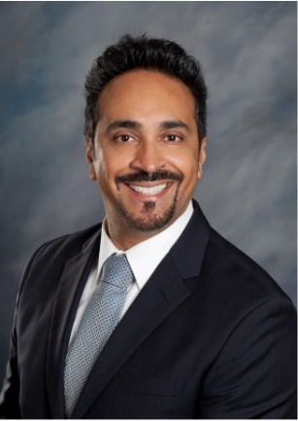
Webinar Date & Time:
Sunday, AUG 2nd , 2026, 8:00 AM – 10:00 AM Pacific Time (US & Canada)
Duration: 2 Hours
Course Description:

Hardev M. Singh DMD, MS.

Dr. Singh was awarded his dental degree from the University of Pittsburgh, School of Dental Medicine, while being a dental student he was awarded the Health Professional Scholarship Program (HPSP) from the United States Army. As a commissioned dental officer, he was awarded the Army Service Ribbon, Global War on Terrorism Service Medal, and the Army Commendation Medal. After serving the Army, Dr. Singh was an Associate Professor at Western University providing clinical dental care with a focus on complex exodontia and pre-prosthetic surgery.
While working in academia he was the owner of a dental practice, however his passion to continue to advance himself led him to become a Periodontic resident at the prestigious Loma Linda University with the focus on advanced periodontal surgery and implant therapy. At Loma Linda he graduated as chief resident and received training from worldwide clinicians. He still holds his academic appointment at Western University as an adjunct faculty. One of the components of his residency training was not only the surgical aspect, but also the importance of non-surgical therapy. As a resident affiliated with various hospitals, the ability to deal with patients with various systemic & pain management issues from various backgrounds provided to be extremely important during residency.

RESPONSIBILITIES AND REQUIREMENTS OF PRESCRIBING SCHEDULE II OPIOID DRUGS
At this current time the widespread abuse and usage of numerous opioids in the country has reached to an epidemic level bringing up awareness in society. At this time the effects of abuse has led to extremely tragic and dangerous outcomes on both individuals and their families. Prevention of such calamities by educating patients and changing or modifying prior prescribing methods by all providers can be helpful going forward. By incorporating proper education tools for patients and doing adequate post-operative care providers can minimize opioid abuse that is extremely prevalent at this current moment.

Topics to be covered
- Responsibility of prescribing Schedule II opioids as a health care provider
- Pain management in dentistry
- Regulatory requirements for prescribers
- Regulatory requirements for dispensers
- Procedures for managing vulnerable patients
- Procedures for managing substance use disorder patients.

WEBINAR SPONSORED BY PUNJABI DENTAL SOCIETY

